4 : 1 Multiplexer
Program:
module mux4to1(y,i0,i1,i2,i3,s0,s1);
input i0,i1,i2,i3,s0,s1;
output y;
wire y0,y1,y2,y3,s01,s11;
not (s11,s1);
not(s01,s0);
and (y0,i0,s01,s11);
and (y1,i1,s0,s11);
and (y2,i2,s01,s1);
and (y3,i3,s0,s1);
or (y,y0,y1,y2,y3);
endmodule

Testbench:
`timescale 1ns/1ps
module muxtest_v;
reg a,b,c,d,s1,s0;
wire z;
mux4to1 m1(z,a,b,c,d,s1,s0);
initial
begin
a=0; b=1; c=1; d=0; s1=0; s0=0;
#50 s1=0; s0=1;
#50 s1=1; s0=0;
#50 s1=1; s0=1;
#50;
end
endmodule

Wave form:
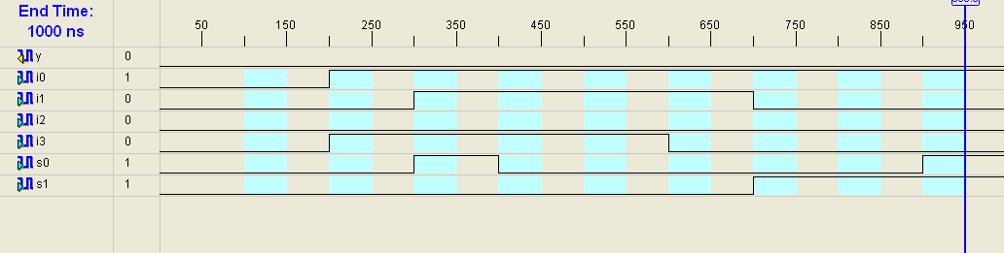
RTL Schematic:
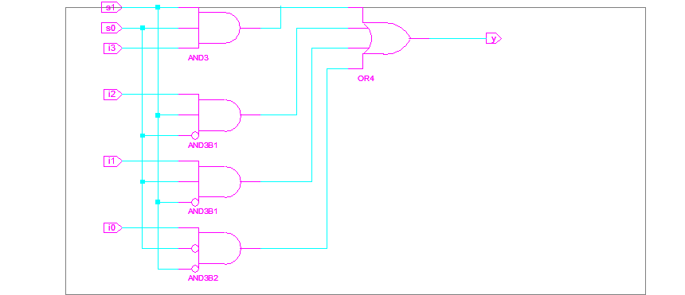

Technology Schematic:
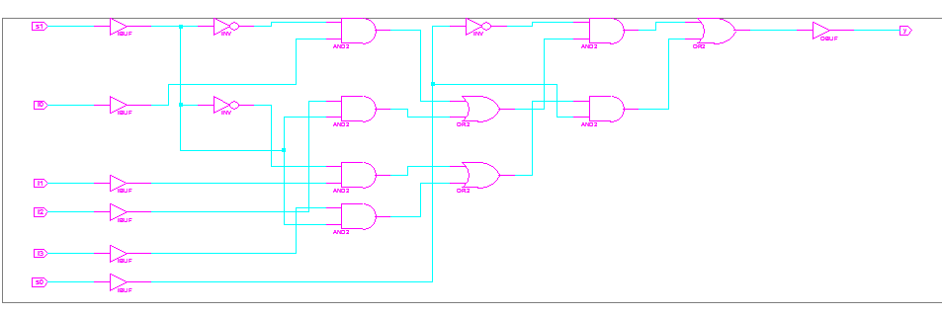
=========================================================================
* Final Report *
=========================================================================
Final Results
RTL Top Level Output File Name : mux4to1.ngr
Top Level Output File Name : mux4to1
Output Format : NGC
Optimization Goal : Speed
Keep Hierarchy : YES
Target Technology : CoolRunner XPLA3 CPLDs
Macro Preserve : YES
XOR Preserve : YES
Clock Enable : YES
wysiwyg : NO
Design Statistics
# IOs : 7
Cell Usage :
# BELS : 12
# AND2 : 6
# INV : 3
# OR2 : 3
# IO Buffers : 7
# IBUF : 6
# OBUF : 1
=========================================================================
CPU : 1.51 / 1.70 s | Elapsed : 2.00 / 2.00 s
-->
Total memory usage is 115608 kilobytes
Number of errors : 0 ( 0 filtered)
Number of warnings : 0 ( 0 filtered)
Number of infos : 0 ( 0 filtered)

