This is to certify that the project entitled
ROBOT DRIVING CIRCUIT USING 8051
ARITHMETIC & LOGICAL UNIT (VHDL)
Is a bonafide work and it is submitted to the P.V.P.P College of Engineering
(Affiliated to University Of Mumbai)
Submitted By
BHUMISH JOSHI - 2015
PRIYA KULKARNI - 1016
NIRMALA KURADE - 1047

Submitted in the partial fulfillment of the requirement for 3rd Year Engineering (Electronics) during the academic year 2012-2013

Under the Guidance of:

Prof. Riddhi Sanghvi Prof. Priti Tyagi
Guide Head of
Department of Electronics Engg. Department of Electronics Engg.
P.V.P.P College of Engg. P.V.P.P College of Engg.

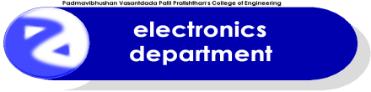

Project Report
For
ROBOT DRIVING CIRCUIT USING 8051
ARITHMETIC & LOGICAL UNIT (VHDL)
Submitted in the partial fulfillment of the requirement for
Third Year Engineering
(Electronics Engineering)

Subject: Electronic Workshop
Submitted By
BHUMISH JOSHI - 2015
PRIYA KULKARNI - 1016
NIRMALA KURADE - 1047

Under the Guidance of:

Prof. Riddhi Sanghvi Prof. Priti Tyagi
Guide Head of
Department of Electronics Engg. Department of Electronics Engg.
P.V.P.P College of Engg. P.V.P.P College of Engg.

ACKNOWLEDGEMENT

ACKNOWLEGMENT

AT THIS POINT OF SUCCESSFUL COMPLETION AND SUBMISSION OF OUR PROJECTS WE WOULD LIKE TO EXPRESS OUR GRATITUDE TOWARDS ALL WHO HAVE HELPED US DIRECTLY OR INDIRECTLY IN DOING OUR PROJECT WORK. THE FIRST AND FOREMOST WE WOULD LIKE TO THANK TO HEAD OF DEPARTMENT OF ELECTRONICS DEPARTMENT PROF. PRITI TYAGI FOR ALLOWING US TO DO THE PROJECT WORK IN LAB & TO USE THE TOOLS OF LAB. WE WOULD ALSO LIKE TO THANK TO PROF. RIDDHI SANGHVI FOR CONTRIBUTING THEIR VALUABLE TIME & PROVIDING US A LOT OF TECHNICAL KNOWLEDGE & TECHNIQUES.

LAST BUT NOT THE LEAST WE WOULD LIKE TO EXPRESS OUR DEEP GRATITUDE TOWARDS ALL PROFESSORS FOR THEIR VALUABLE & TIMELY HELP. AT LAST WE WOULD LIKE TO THANK OUR LAB ASSISTANTS FOR THEIR CO−OPERATION OF THIS PROJECT SUCCESSFULLY.

INDEX

ROBOT DRIVING CIRCUIT USING 8051………............................................6

ARITHMETIC LOGICAL UNIT (VHDL)………………………………….……..…16

COMPONENTS WHICH ARE USED……………………..................................24

DATASHEET……………………………………………………………………….………...32

ROBOT DRIVING CIRCUIT

USING 8051

ABSTRACT:

The reason behind selecting this project is to have a good understanding of microcontroller (8051 family), current driver IC (ULN2003), and programming (assembly language).

We have implemented this project on copper clad PCB for that we have used EAGLE software.

Currently this circuit has limited features (4 motor) but features can be expanded by using some extra sockets available at port no. 2.

Robot driving circuit can be used at various events such as in robotics games during technical festivals.

CIRCUIT DIAGRAM:

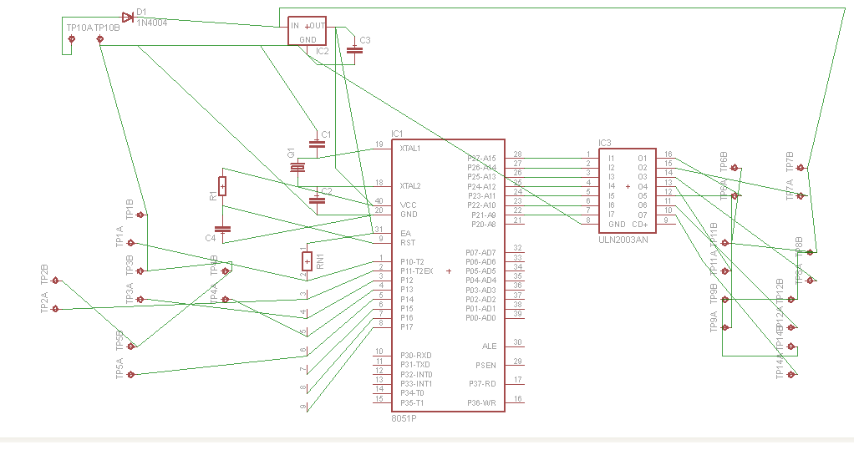

EXPLAINATION:

Here is a simple but effective robot driving circuit that is based on 8051 family microcontrollers. 5 tack switches (4 for selecting direction of robot like forward, left, right, and back & 1 for selecting speed) are used for getting input. These switches are connected to P1.0 to P1.4. Pull up resistors are connected to port 1 so that when someone presses any button, microcontroller gets logic 0 on respective pin. Now the program is written in such a way that when any switch presses, the motors which can lead robot to respective direction will be turned on.

The current output capacity of microcontroller is very less (in mille amperes) which is not able to run motor directly & the other limitation about directly driving motor is that at output we have only 1 choice of 5 volt. Hence motor driving or current amplifier or Darlington amplifier (common collector configuration) IC ULN 2003 is used which increases current capacity of signal up to .5 ampere & voltage up to 50 volts. In our application we have used 12 volt power supply.

ULN2003 IC is connected at port 2.1 to 2.7 of 89c51. R1 & C4 is used to momentarily give logic 0 to active low reset input of microcontroller. C3 is used for filtering purpose. Diode D1 is used to avoid negative power supply. TP10A (+) & TP10B (-) are power supply input for the circuit. EA pin is connected to 5 volt in order to access only internal ROM. 7805 IC is used to convert +12 v to +5v.

PCB LAYOUT (with components):
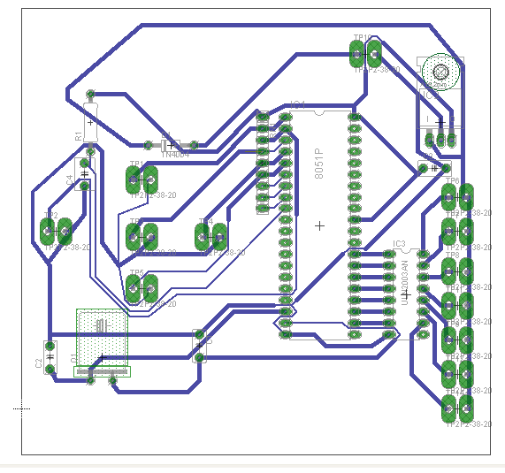

PCB LAYOUT (without components):
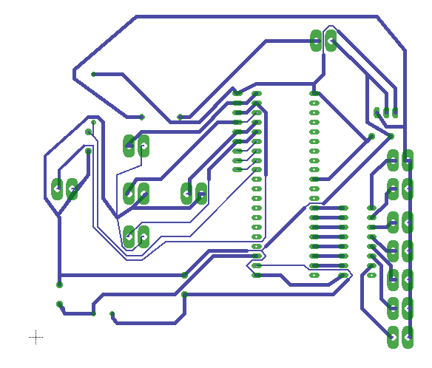

PROGRAM:

ORG 0000H
AJMP START

ORG 0030H
START: CLR P2.7
CLR P2.5
CLR P2.3
CLR P2.1
SETB P2.6
SETB P2.4
SETB P2.2
SETB P2.0
JNB P1.0,FOR
JNB P1.1,LEF
JNB P1.2,ALL
JNB P1.3,RIG
JNB P1.4,BCK
AJMP START

FOR: SETB P2.7
SETB P2.5
CLR P2.3
CLR P2.1
JNB P1.0,FOR
AJMP START

LEF: SETB P2.7
SETB P2.3
CLR P2.5
CLR P2.1
JNB P1.1,LEF
AJMP START

ALL: SETB P2.7
SETB P2.5
SETB P2.3
SETB P2.1
JNB P1.2,ALL
AJMP START

RIG: SETB P2.5
SETB P2.1
CLR P2.7
CLR P2.3
JNB P1.3,RIG
AJMP START

BCK: CLR P2.7
CLR P2.5
SETB P2.3
SETB P2.1
JNB P1.4,BCK
AJMP START

END

ADVANTAGES:
- LOW COST
- LESS COMPONENTS
- SIMPLE CIRCUIT
- TWO SPEED CONTROL

ARITHMETIC LOGICAL UNIT (VHDL)

INTRODUCTION:

VHDL (VHSIC hardware description language) is a hardware description language used in electronic design automation to describe digital and mixed-signal systems such as field-programmable gate arrays and integrated circuits. VHDL was originally developed at the behest of the U.S Department of Defense in order to document the behavior of the ASICs that supplier companies were including in equipment. That is to say, VHDL was developed as an alternative to huge, complex manuals which were subject to implementation-specific details.

DESIGN:

VHDL is commonly used to write text models that describe a logic circuit. Such a model is processed by a synthesis program, only if it is part of the logic design. A simulation program is used to test the logic design using simulation models to represent the logic circuits that interface to the design. This collection of simulation models is commonly called a test bench.

VHDL has constructs to handle the parallelism inherent in hardware designs, but these constructs (processes) differ in syntax from the parallel constructs in Ada (tasks). Like Ada, VHDL is strongly typed and is not case sensitive. In order to directly represent operations which are common in hardware, there are many features of VHDL which are not found in Ada, such as an extended set of Boolean operators including nand and nor. VHDL also allows arrays to be indexed in either ascending or descending direction; both conventions are used in hardware, whereas in Ada and most programming languages only ascending indexing is available.

VHDL has file input and output capabilities, and can be used as a general-purpose language for text processing, but files are more commonly used by a simulation test bench for stimulus or verification data. There are some VHDL compilers which build executable binaries. In this case, it might be possible to use VHDL to write a test bench to verify the functionality of the design using files on the host computer to define stimuli, to interact with the user, and to compare results with those expected. However, most designers leave this job to the simulator.

A final point is that when a VHDL model is translated into the "gates and wires" that are mapped onto a programmable logic device such as a CPLD or FPGA, and then it is the actual hardware being configured, rather than the VHDL code being "executed" as if on some form of a processor chip.

ADVANTAGES:

The key advantage of VHDL, when used for systems design, is that it allows the behavior of the required system to be described (modeled) and verified (simulated) before synthesis tools translate the design into real hardware (gates and wires).

Another benefit is that VHDL allows the description of a concurrent system. VHDL is a dataflow language, unlike procedural computing languages such as BASIC, C, and assembly code, which all run sequentially, one instruction at a time.

VHDL project is multipurpose. Being created once, a calculation block can be used in many other projects. However, many formational and functional block parameters can be tuned (capacity parameters, memory size, element base, block composition and interconnection structure).
VHDL project is portable. Being created for one element base, a computing device project can be ported on another element base, for example VLSI with various technologies.
ABSTRACT:

ALU (Arithmetic Logic Unit) is a digital circuit which does arithmetic and logical operations. It’s a basic block in any processor.
This is one of the simplest architecture of an ALU. Most of the ALU's used in practical designs are far more complicated and requires good design experience.
The block diagram of the ALU is given below. It receives two input operands 'A' and 'B' which are 8 bits long. The result is denoted by 'R' which is also 8 bit long. The input signal 'Op' is a 3 bit value which tells the ALU what operation to be performed by the ALU. Since 'Op' is 3 bits long we can have 2^3=8 operations.

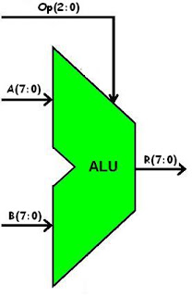

ALU Operation | Description
Add Signed | R = A + B: Treating A, B, and R as signed two's complement integers.
Subtract Signed | R = A - B: Treating A, B, and R as signed two’s complement integers.
Bitwise AND | R(i) = A(i) AND B(i).
Bitwise NOR | R(i) = A(i) NOR B(i).
Bitwise OR | R(i) = A(i) OR B(i).
Bitwise NAND | R(i) = A(i) NAND B(i).
Bitwise XOR | R(i) = A(i) XOR B(i).
Bitwise NOT | R(i) = NOT A(i).

VHDL program for 8 bit Arithmetic Logical Unit

library IEEE;
use IEEE.STD_LOGIC_1164.ALL;
use IEEE.NUMERIC_STD.ALL;

entity alu is
port( Clk : in std_logic; --clock signal
A,B : in signed(7 downto 0); --input operands
Op : in unsigned(2 downto 0); --Operation to be performed
R : out signed(7 downto 0) --output of ALU
);
end alu;

architecture Behavioral of alu is

--temporary signal declaration.
signal Reg1,Reg2,Reg3 : signed(7 downto 0) := (others => '0');

begin

Reg1 <= A;
Reg2 <= B;
R <= Reg3;

process(Clk)
begin

if(rising_edge(Clk)) then --Do the calculation at the positive edge of clock cycle.
case Op is
when "000" =>
Reg3 <= Reg1 + Reg2; --addition
when "001" =>
Reg3 <= Reg1 - Reg2; --subtraction
when "010" =>
Reg3 <= not Reg1; --NOT gate
when "011" =>
Reg3 <= Reg1 nand Reg2; --NAND gate
when "100" =>
Reg3 <= Reg1 nor Reg2; --NOR gate
when "101" =>
Reg3 <= Reg1 and Reg2; --AND gate
when "110" =>
Reg3 <= Reg1 or Reg2; --OR gate
when "111" =>
Reg3 <= Reg1 xor Reg2; --XOR gate
when others =>
NULL;
end case;
end if;

end process;

end Behavioral;

WAVEFORM:

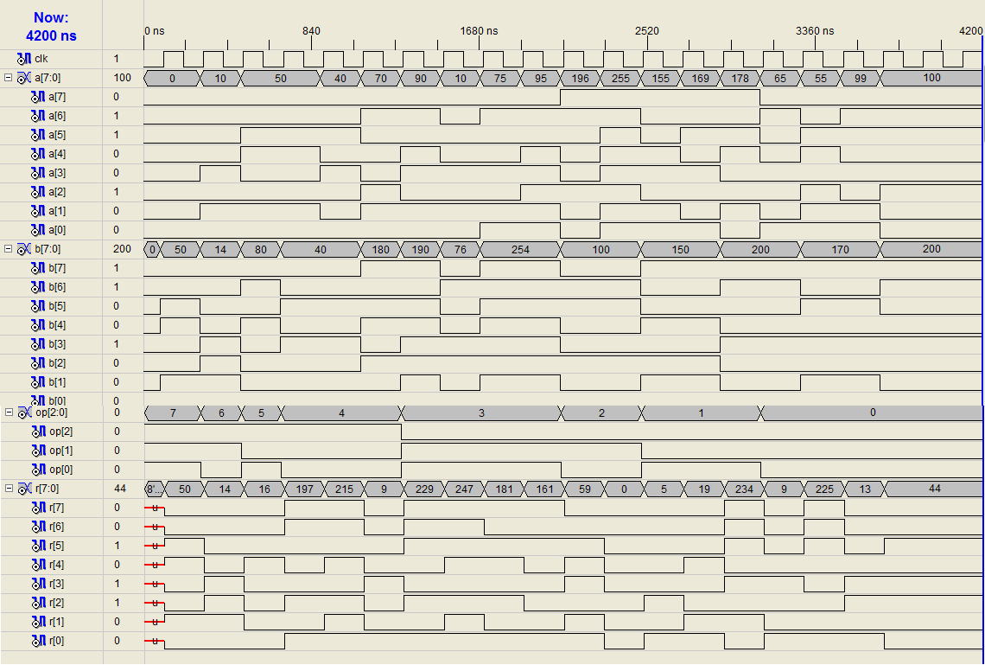

COMPONENTS WHICH ARE USED

MOTOR:

There are three types of connections used for DC electric motors: series, shunt and compound. These types of connections configure how the motor's field and armature windings are connected together. The type of connection is significant because it determines the characteristics of the motor and is selected for speed/torque requirements of the load.

DC brushed motor. Like stepper motor, it is also open loop motor [no rotor’s position feedback system is there]. But main difference between both of them is stepper motor is a synchronous motor & DC brushed motor is an asynchronous motor.

In DC brushed motor there is only two wires are connected to motor & both are used for power supply. As name implies we have to supply dc power to start/run this motor. This is not the constant speed motor [like stepper] but this is the constant power motor. So any change in load will effect inversely on the speed of the motor. It can be used as generator also if we give i/p to the shaft & take o/p from power supply wires.

If we want to start/run motor through o/p signals of microprocessor then we have to amplify the both current & voltage of that signals. In this motor, rotor consists of electromagnet or coil & stator consists of permanent magnet. Brushes are used to just transfer the power to the coil depending on the position of rotor.

In the following image you can see the basic construction of dc brushed motor. You can see that on the shaft there is rounded metal plate of conductor & it is called as brushes [it is of very basic version]. Stator consists of blue coloured north & red coloured south permanent magnet. If we give the voltages to the motor according the sign on the image then it will move clockwise & if we give the voltages reverses to the sign on the image then motor will move anticlockwise. Motor’s o/p power is depending on the voltage applied across the two terminal of the motor.

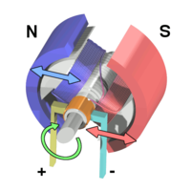

Now when we give i/p voltage according to the sign convention of above image, then it will create magnetic field across rotor, which is similar to the field created by permanent magnet. So it will create repulsion & then attraction. Due to that rotor moves [in clockwise direction], which create motion & finally it is given to the o/p by the means of shaft.

ULN 2003:

It is expected that motor will draw very high current to run. This high amount of current [in milliamps] is not possible to supply through microprocessor. So here we are using a current amplifier IC [2003], to amplify the current.
In this amplifier IC there is Darlington’s array between each i/p & o/p. as you can see in the below image, Darlington’s array consists of two transistors. In which collector’ supply is common for both & one transistor’s emitter is connected to other’s base. The o/p is available at the collector of the transistor. I/p are connected to microprocessor & o/p is to motor.

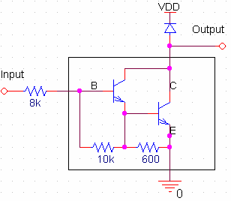

This IC takes signal of microprocessor as voltage simple & gives it to the transistor’s base to amplify it. Here there is one resistor of 8K to limit the base current. Base current is very small [normally 100 times smaller than collector current], so it will not damage to the microprocessor. Boxed content in the image is known as Darlington’s array. Here one diode is used because when there is no voltage applied at i/p terminal of IC then at o/p terminal we can give the o/p as VDD.

Now when the positive pulse is given to i/p terminal then the transistors will allow the flow of current through its collector & emitter from o/p terminal to ground. Here there are two transistors used so both will divide the current. VDD should be positive with respect to ground. Diode is used for protection purpose.

IC 7805:

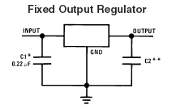 | 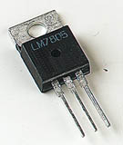

The 7805 monolithic3-terminal positive voltage regulators employ internal current-limiting, thermal shutdown and safe-area compensation, making them essentially indestructible. If adequate heat sinking is provided, they can deliver over 1.0A output current. They are intended as fixed voltage regulators in a wide range of applications including local (on-card) regulation for elimination of noise and distribution problems associated with single-point regulation. In addition to use as fixed voltage regulators, these devices can be used with external components to obtain adjustable output voltages and currents.

It is not necessary to bypass the output, although this does improve transient response. Input bypassing is needed only if the regulator is located far from the Filter capacitor of the power supply.

PULL UP RESISTORS:

Pull-up resistors are used in electronic logic circuits to ensure that inputs to logic systems settle at expected logic levels if external devices are disconnected or high-impedance. They may also be used at the interface between two different types of logic devices, possibly operating at different power supply voltages.

A pull-up resistor weakly "pulls" the voltage of the wire it is connected to towards its voltage source level when the other components on the line are inactive. When all other connections on the line are inactive, they are high-impedance and act like they are disconnected. Since the other components act as though they are disconnected, the circuit acts as though it is disconnected, and the pull-up resistor brings the wire up to the high logic level. When another component on the line goes active, it will override the high logic level set by the pull-up resistor. The pull-up resistor assures that the wire is at a defined logic level even if no active devices are connected to it.
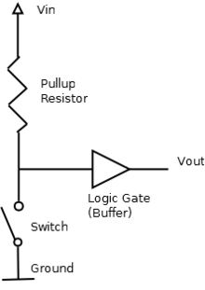

When the switch is open the voltage of the gate input is pulled up to the level of Vin. When the switch is closed, the input voltage at the gate goes to ground.
CRYSTAL:

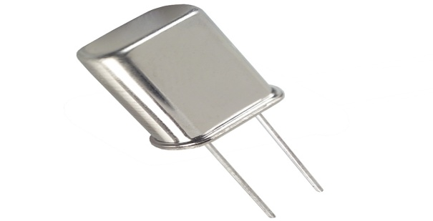

A crystal oscillator is an electronic oscillator circuit that uses the mechanical resonance of a vibrating crystal of piezoelectric material to create an electrical signal with a very precise frequency. This frequency is commonly used to keep track of time (as in quartz wristwatches), to provide a stable clock signal for digital integrated circuits, and to stabilize frequencies for transmitters and receivers. The most common type of piezoelectric resonator used is the quartz crystal, but other piezoelectric materials including polycrystalline ceramics are used in similar circuits.

Quartz crystals are manufactured for frequencies from a few tens of kilohertz to tens of megahertz. More than two billion crystals are manufactured annually. Most are used for consumer devices such as wristwatches, clocks, radios, computers, and cell phones. Quartz crystals are also found inside test and measurement equipment, such as counters, signal generators, and oscilloscopes.

DATASHEET

