EXPERIMENT NO 5 : Half Adder ,Full Adder ,4 Bit full Adder
Half Adder
Program:
module ha(s,c,a,b);
input a,b;
output s,c;
wire s1,c1,c2;
xor(s1,a,b);
and(c1,a,b);
xor(s,s1);
and(c2,s1);
xor(c2,c1);
endmodule
Testbench:
`timescale 1ns/1ps
module fatest_v;
reg a,b;
wire s;
ha uut(s,c,a,b);
initial
begin
a=0;b=0;
#50 a=0; b=1;
#50 a=1; b=0;
#50 a=1; b=1;
#50;
end
endmodule

Waveforms:
Half adder:

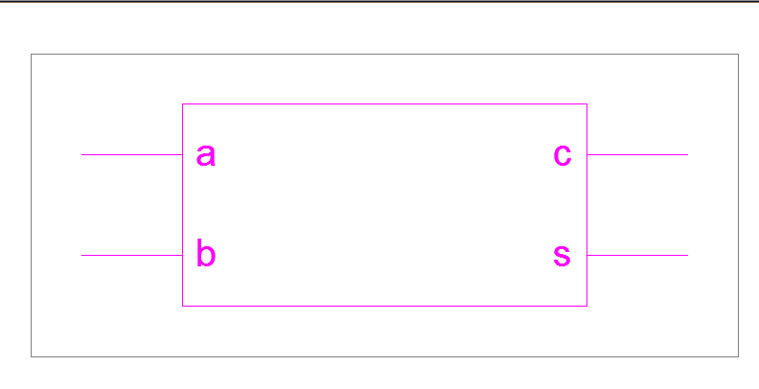
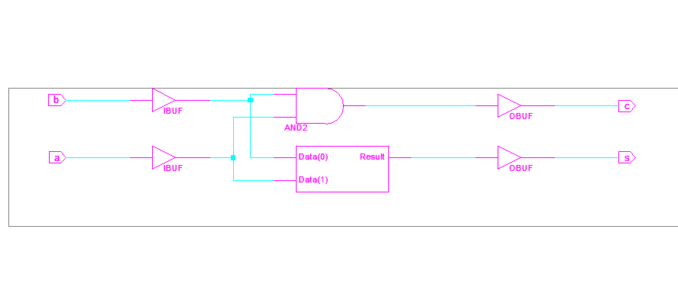

Final Results
RTL Top Level Output File Name : ha1.ngr
Top Level Output File Name : ha1
Output Format : NGC
Optimization Goal : Speed
Keep Hierarchy : YES
Target Technology : Automotive 9500XL
Macro Preserve : YES
XOR Preserve : YES
Clock Enable : YES
wysiwyg : NO
Design Statistics
# IOs : 4
Cell Usage :
# BELS : 2
# AND2 : 1
# XOR2 : 1
# IO Buffers : 4
# IBUF : 2
# OBUF : 2
CPU : 1.41 / 1.56 s | Elapsed : 2.00 / 2.00 s
Total memory usage is 114468 kilobytes
Number of errors : 0 ( 0 filtered)
Number of warnings : 0 ( 0 filtered)
Number of infos : 0 ( 0 filtered)

Full adder:
Program:
module fa(s,cn,a,b,an);
input a,b,an;
output s,cn;
wire s1,c1,c2;
xor(s1,a,b);
and(c1,a,b);
xor(s,s1,an);
and(c2,s1,an);
xor(cn,c2,c1);
endmodule

Test bench:
`timescale 1ns/1ps
module fatest_v;
reg a,b,an;
wire s,cn;
fa uut(s,cn,a,b,an);
initial
begin
a=0;b=0;an=0;
#50 a=0; b=0;an=0;
#50 a=0; b=0;an=1;
#50 a=0; b=1;an=0;
#50 a=0; b=1;an=1;
#50 a=1; b=0;an=0;
#50 a=1; b=0;an=1;
#50 a=1; b=1;an=0;
#50 a=1; b=1;an=1;
#50;
end
endmodule
Waveform:
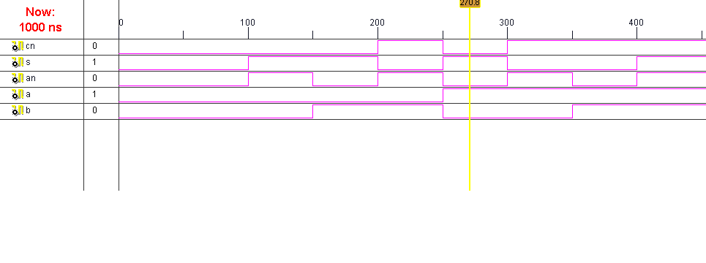
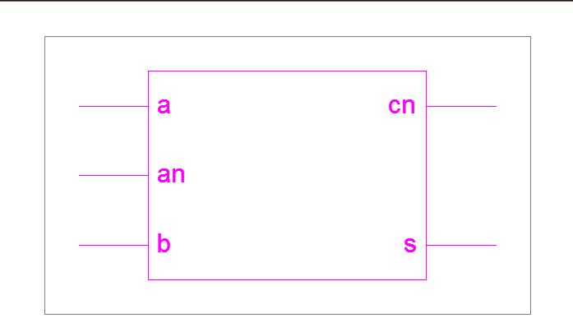
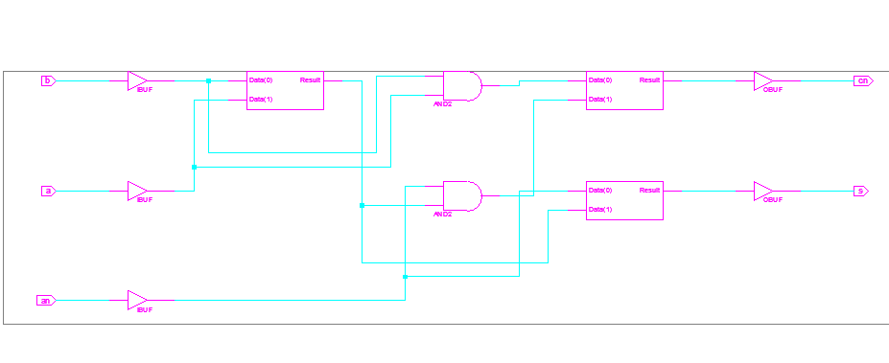
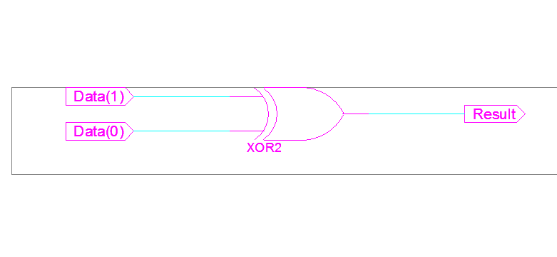

Final Report:

=========================================================================
* Final Report *
=========================================================================
Final Results
RTL Top Level Output File Name : fa.ngr
Top Level Output File Name : fa
Output Format : NGC
Optimization Goal : Speed
Keep Hierarchy : YES
Target Technology : Automotive 9500XL
Macro Preserve : YES
XOR Preserve : YES
Clock Enable : YES
wysiwyg : NO

Design Statistics
# IOs : 5

Cell Usage :
# BELS : 5
# AND2 : 2
# XOR2 : 3
# IO Buffers : 5
# IBUF : 3
# OBUF : 2
=========================================================================
CPU : 1.42 / 1.58 s | Elapsed : 2.00 / 2.00 s

-->

Total memory usage is 133320 kilobytes

Number of errors : 0 ( 0 filtered)
Number of warnings : 0 ( 0 filtered)
Number of infos : 0 ( 0 filtered)

