%-----RAMP RESPONSE---- DATE 15/01/2013
BATCH C

num=[0 0 25];
den=[1 6 25];
t=0:0.1:10;
r=t;
y=lsim(num,den,r,t);
plot(t,r,'-',t,y,'o')
grid
title('UNIT RAMP RESPONSE')
xlabel('tsec')
ylabel('r(t) and c(t)')
text(2.0,3.0,'r(t)')
text(4.0,2.0,'c(t)')

OUTPUT:
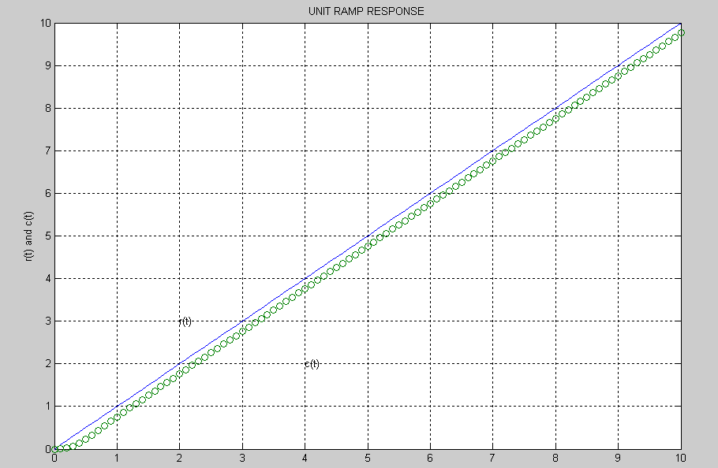

SIMULATION

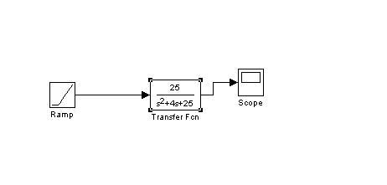
OUTPUT AFTER SIMULATION :
