FSM for detecting 1010 overlapping sequence
library IEEE;
use IEEE.STD_LOGIC_1164.ALL;
use IEEE.STD_LOGIC_ARITH.ALL;
use IEEE.STD_LOGIC_UNSIGNED.ALL;
entity seq1010 is
Port ( x,clk : in STD_LOGIC;
z : out STD_LOGIC);
end seq1010;
architecture Behavioral of seq1010 is
Type state is (A, B, C, D);
signal y: state;
begin
Process(clk)
begin
If(clk'event and clk = '1') then
case y is
when A =>
If(x = '0') then y <= A; z <= '0';
Else y <= B; z <= '0';
End If;
when B =>
If(x = '0') then y <= C; z <= '0';
Else y <= B; z <= '0';
End If;

when C =>
If(x = '0') then y <= A; z <= '0';
Else y <= D; z <= '0';
End If;
when D =>
If(x = '0') then y <= C; z <= '1';
Else y <= B; z <= '0';
End If;
End Case;
End If;
End Process;
end Behavioral;

FSM for detecting 1010 overlapping sequence

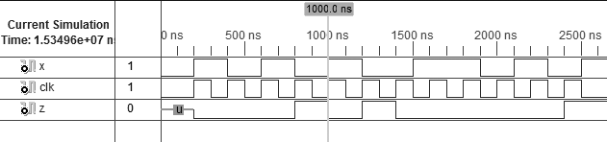

JK FLIP-FLOP WITH ASYNCHRONOUS CLEAR & SYNCHRONOUS PRESET
library IEEE;
use IEEE.STD_LOGIC_1164.ALL;
use IEEE.STD_LOGIC_ARITH.ALL;
entity jkff is
Port ( j : in STD_LOGIC;
k : in STD_LOGIC;
clk : in STD_LOGIC;
q : out STD_LOGIC;
qbar : out STD_LOGIC;
pr : in STD_LOGIC;
clr : in STD_LOGIC);
end jkff;
architecture Behavioral of jkff is
signal temp: std_logic;
begin
Process (clr, clk, pr)
Begin
If(clr = '0') then temp<='0';
ElsIf(clk'event AND clk = '0') then
If(pr = '0') then temp<= '1';
Else
If(j = '0' AND k = '1') then temp <= '0';
ElsIf(j = '1' AND k = '0') then temp <= '1';
ElsIf(j = '1' AND k = '1') then temp <= not temp;

End If;
End If;
End If;
End Process;
q <= temp;
qbar <= not temp;
end Behavioral;

JK FLIP-FLOP WITH ASYNCHRONOUS CLEAR & SYNCHRONOUS PRESET
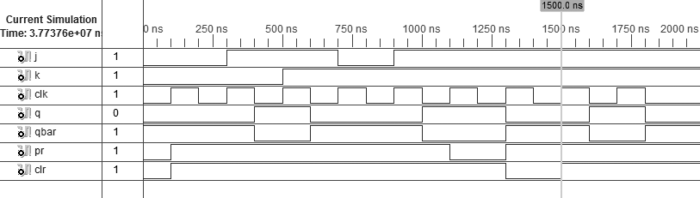

3:8 DECODER USING WHEN-ELSE
library IEEE;
use IEEE.STD_LOGIC_1164.ALL;
use IEEE.STD_LOGIC_ARITH.ALL;
use IEEE.STD_LOGIC_UNSIGNED.ALL;
entity decoder is
Port ( data : in STD_LOGIC_VECTOR (02 downto 0);
output : out STD_LOGIC_VECTOR (07 downto 0));
end decoder;
architecture Dataflow of decoder is
begin
output <=
"11111110" when data = "000" else
"11111101" when data = "001" else
"11111011" when data = "010" else
"11110111" when data = "011" else
"11101111" when data = "100" else
"11011111" when data = "101" else
"10111111" when data = "110" else
"01111111" when data = "111";
end Dataflow;

3:8 DECODER USING WHEN-ELSE
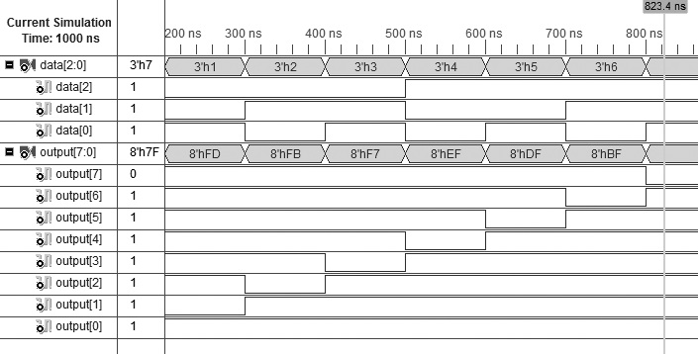

16 Bit Barrel Shifter
library IEEE;
use IEEE.STD_LOGIC_1164.ALL;
use IEEE.STD_LOGIC_ARITH.ALL;
use IEEE.STD_LOGIC_UNSIGNED.ALL;
entity barrel_shift is
port( DIN : in std_logic_vector(15 downto 0);
SHIFT_AMT : in std_logic_vector(3 downto 0);
CLK, ENB : in std_logic;
DOUT : out std_logic_vector (15 downto 0));
end barrel_shift;
architecture Behavioral of barrel_shift is
signal DIN_BIT, DOUT_BIT : bit_vector (15 downto 0);
signal S_INT : integer;
begin
DIN_BIT <= to_bitvector(DIN);
S_INT <= CONV_INTEGER(SHIFT_AMT);
process(CLK)
begin
if(CLK' event and CLK='1') then
if(ENB = '0') then
DOUT <= DIN;
else

DOUT_BIT <= DIN_BIT ror S_INT;
DOUT <= to_stdlogicvector(DOUT_BIT);
end if;
end if;
end process;
end Behavioral;

