-------------------------------------4 Bit Ring Counter (LEFT SHIFT) USING IF ELSE---------------------------------------------
library IEEE;
use IEEE.STD_LOGIC_1164.ALL;
use IEEE.STD_LOGIC_ARITH.ALL;
use IEEE.STD_LOGIC_UNSIGNED.ALL;
entity ringcounter is
Port ( data : in STD_LOGIC_VECTOR (03 downto 0);
output : out STD_LOGIC_VECTOR (03 downto 0);
clk, clr, l : in STD_LOGIC);
end ringcounter;
architecture Behavioral of ringcounter is
signal temp: std_logic_vector(3 downto 0);
begin
process(clk, clr, l)
begin
If (clr = '1') then temp <= "0000";
ElsIf (l = '1') then temp <= data;
ElsIf (clk'event and clk = '1') then
temp <= temp(2 downto 0)&temp(3);
End If;
End Process;
output <= temp;
end Behavioral;

-------------------------------------4 Bit Ring Counter (LEFT SHIFT) USING IF ELSE---------------------------------------------
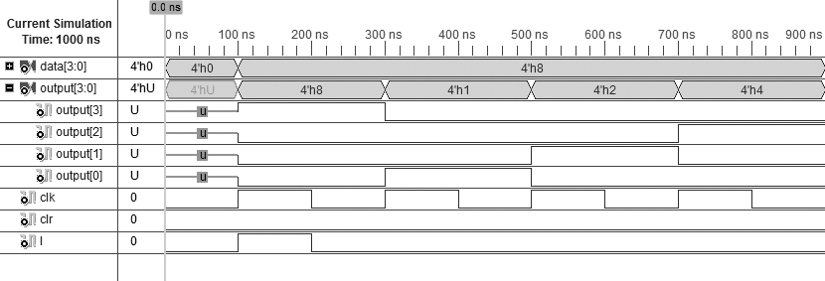

-------------------------------------4 Bit Twisted Ring Counter USING IF ELSE---------------------------------------------
library IEEE;
use IEEE.STD_LOGIC_1164.ALL;
use IEEE.STD_LOGIC_ARITH.ALL;
use IEEE.STD_LOGIC_UNSIGNED.ALL;
entity twistedringcounter is
Port ( data : in STD_LOGIC_VECTOR (03 downto 0);
output : out STD_LOGIC_VECTOR (03 downto 0);
clk, clr, l: in STD_LOGIC);
end twistedringcounter;
architecture Behavioral of twistedringcounter is
signal temp: std_logic_vector(3 downto 0);
begin
process(clk, clr)
begin
If (clr = '1') then temp <= "0000";
ElsIf (l = '1') then temp <= data;
ElsIf (clk'event and clk = '1') then
temp <= temp(2 downto 0)&not(temp(3));
End If;
End Process;
output <= temp;
end Behavioral;

-------------------------------------4 Bit Twisted Ring Counter USING IF ELSE---------------------------------------------
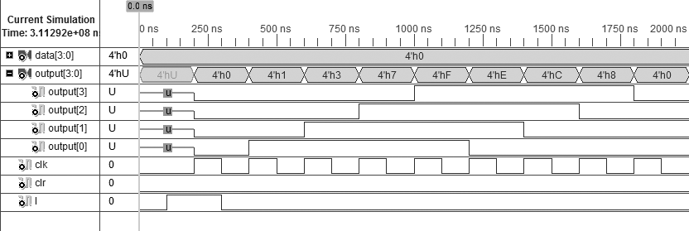
-------------------------------------8 Bit Bidirectional Shift Register USING IF ELSE---------------------------------------------
library IEEE;
use IEEE.STD_LOGIC_1164.ALL;
use IEEE.STD_LOGIC_ARITH.ALL;
use IEEE.STD_LOGIC_UNSIGNED.ALL;
entity bireg is
Port ( din : in STD_LOGIC;
sin : in STD_LOGIC;
m : in STD_LOGIC;
clk : in STD_LOGIC;
clr : in STD_LOGIC;
sl : out STD_LOGIC;
sr : out STD_LOGIC);
end bireg;
architecture Behavioral of bireg is
signal temp: std_logic_vector(7 downto 0);
begin
process (clk,clr)
begin
If(clr = '0') then temp<="00000000";
ElsIf(clk'event and clk = '0') then
If(m = '1') then temp <= din & temp(6 downto 0);
Else temp <= temp(7 downto 1) & sin;
End If; End If;

End Process;
sr <= temp(7);
sl <= temp(0);
end Behavioral;

-------------------------------------8 Bit Bidirectional Shift Register USING IF ELSE---------------------------------------------
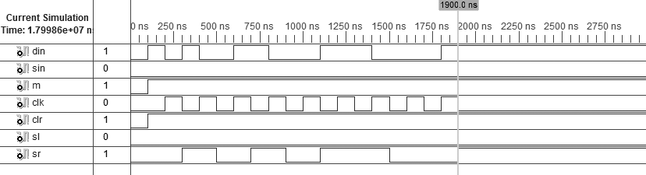

-------------------------------------DECODER 3:8 USING CASE---------------------------------------------
library IEEE;
use IEEE.STD_LOGIC_1164.ALL;
use IEEE.STD_LOGIC_ARITH.ALL;
use IEEE.STD_LOGIC_UNSIGNED.ALL;

---- Uncomment the following library declaration if instantiating
---- any Xilinx primitives in this code.
--library UNISIM;
--use UNISIM.VComponents.all;

entity DEOCDER38CASE1 is
Port ( D : in STD_LOGIC_VECTOR (02 downto 0);
Y : out STD_LOGIC_VECTOR (07 downto 0));
end DEOCDER38CASE1;

architecture Behavioral of DEOCDER38CASE1 is
begin
PROCESS(D)
BEGIN
CASE D IS
WHEN "000" => Y <= "00000001";
WHEN "001" => Y <= "00000010";
WHEN "010" => Y <= "00000100";
WHEN "011" => Y <= "00001000";
WHEN "100" => Y <= "00010000";
WHEN "101" => Y <= "00100000";
WHEN "110" => Y <= "01000000";
WHEN "111" => Y <= "10000000";
WHEN OTHERS => Y <= "ZZZZZZZZ";
END CASE;
END PROCESS;
end Behavioral;

-------------------------------------DECODER 3:8 USING CASE---------------------------------------------
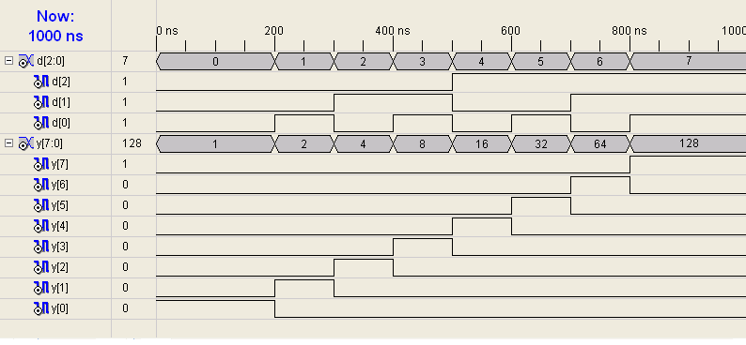

-------------------------------------4 BIT ADDER USING STRUCTURAL MODEL---------------------------------------------
-- PROGRAM FOR 1 BIT ADDER
library IEEE;
use IEEE.STD_LOGIC_1164.ALL;
use IEEE.STD_LOGIC_ARITH.ALL;
use IEEE.STD_LOGIC_UNSIGNED.ALL;
entity ADDER1BIT is
Port(A : in std_logic;
B : in std_logic;
CO :out std_logic;
CIN : IN STD_LOGIC;
Y : out std_logic);
end ADDER1BIT;
ARCHITECTURE DATAFLOW OF ADDER1BIT IS
BEGIN
Y <= (A XOR B XOR CIN);
CO <= ((A AND B) OR (A AND CIN) OR (B AND CIN));
END DATAFLOW;
-- PROGRAM FOR 4BIT ADDER
library IEEE;
use IEEE.STD_LOGIC_1164.ALL;
use IEEE.STD_LOGIC_ARITH.ALL;
use IEEE.STD_LOGIC_UNSIGNED.ALL;
entity ADDER4STRUCT is
Port ( A : in STD_LOGIC_VECTOR (03 downto 0);
B : in STD_LOGIC_VECTOR (03 downto 0);
CO : out STD_LOGIC;
CIN : in STD_LOGIC;
Y : out STD_LOGIC_VECTOR (03 downto 0));
end ADDER4STRUCT;
architecture STRUCTURAL of ADDER4STRUCT is
COMPONENT ADDER1BIT IS
PORT(A : in std_logic;
B : in std_logic;
CO : out std_logic;
CIN : IN STD_LOGIC;
Y : out std_logic);
end COMPONENT;
SIGNAL TEMPO : STD_LOGIC_VECTOR(3 DOWNTO 0);
SIGNAL TEMP : STD_LOGIC_VECTOR(2 DOWNTO 0);
BEGIN
U1 : ADDER1BIT PORT MAP (A(0),B(0),TEMP(0),CIN,TEMPO(0));
U2 : ADDER1BIT PORT MAP (A(1),B(1),TEMP(1),TEMP(0),TEMPO(1));
U3 : ADDER1BIT PORT MAP (A(2),B(2),TEMP(2),TEMP(1),TEMPO(2));
U4 : ADDER1BIT PORT MAP (A(3),B(3),CO,TEMP(2),TEMPO(3));
Y <= TEMPO;
end STRUCTURAL;
-------------------------------------4 BIT ADDER USING STRUCTURAL MODEL---------------------------------------------
