-------------------------------------BINARY TO GRAY---------------------------------------------
library IEEE;
use IEEE.STD_LOGIC_1164.ALL;
use IEEE.STD_LOGIC_ARITH.ALL;
use IEEE.STD_LOGIC_UNSIGNED.ALL;

entity BINTOGRAY is
Port ( D : in STD_LOGIC_VECTOR (03 downto 0);
Y : out STD_LOGIC_VECTOR (03 downto 0));
end BINTOGRAY;

architecture DATAFLOW of BINTOGRAY is
begin
y(3) <= d(3);
y(2) <= d(3) xor d(2);
y(1) <= d(2) xor d(1);
y(0) <= d(1) xor d(0);
end DATAFLOW;
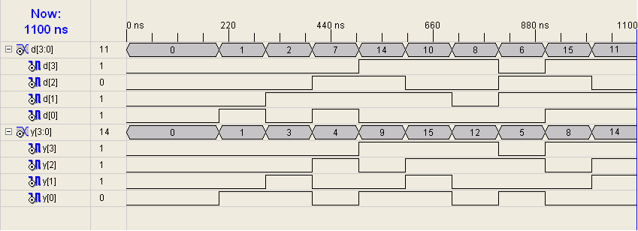
-------------------------------------GRAY TO BINARY---------------------------------------------
library IEEE;
use IEEE.STD_LOGIC_1164.ALL;
use IEEE.STD_LOGIC_ARITH.ALL;
use IEEE.STD_LOGIC_UNSIGNED.ALL;

---- Uncomment the following library declaration if instantiating
---- any Xilinx primitives in this code.
--library UNISIM;
--use UNISIM.VComponents.all;

entity GRAYTOBIN is
Port ( D : in STD_LOGIC_VECTOR (03 downto 0);
Y : out STD_LOGIC_VECTOR (03 downto 0));
end GRAYTOBIN;

architecture Behavioral of GRAYTOBIN is

begin
PROCESS (D)
variable TEMP : STD_LOGIC_VECTOR(3 DOWNTO 0);
BEGIN
TEMP(3) := D(3);
TEMP(2) := (D(2) XOR TEMP(3));
TEMP(1) := (D(1) XOR TEMP(2));
TEMP(0) := (D(0) XOR TEMP(1));
y <= TEMP;
END PROCESS;
end Behavioral;

-------------------------------------GRAY TO BINARY---------------------------------------------

-------------------------------------MUX 4:1 USING EXPRESSION---------------------------------------------
library IEEE;
use IEEE.STD_LOGIC_1164.ALL;
use IEEE.STD_LOGIC_ARITH.ALL;
use IEEE.STD_LOGIC_UNSIGNED.ALL;

entity MUX41EXPR is
Port ( D : in STD_LOGIC_VECTOR (03 downto 0);
S1 : in STD_LOGIC;
S0 : in STD_LOGIC;
Y : out STD_LOGIC);
end MUX41EXPR;

architecture DATAFLOW of MUX41EXPR is
begin
Y <= ((NOT S1) AND (NOT S0) AND D(0)) OR ((NOT S1) AND S0 AND D(1)) OR (S1 AND (NOT S0) AND D(2)) OR (S1 AND S0 AND D(3));
end DATAFLOW;

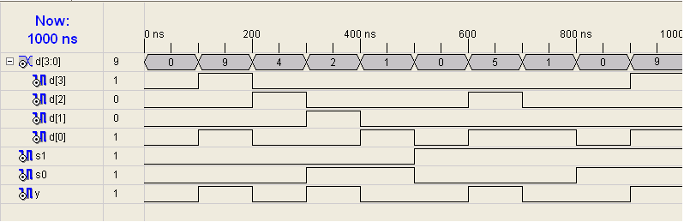
-------------------------------------MUX 4:1 USING CASE---------------------------------------------
library IEEE;
use IEEE.STD_LOGIC_1164.ALL;
use IEEE.STD_LOGIC_ARITH.ALL;
use IEEE.STD_LOGIC_UNSIGNED.ALL;

entity MUX41CASE is
Port ( SEL : in STD_LOGIC_VECTOR (01 downto 0);
D : in STD_LOGIC_VECTOR (03 downto 0);
Y : out STD_LOGIC);
end MUX41CASE;

architecture Behavioral of MUX41CASE is
begin
PROCESS (D,SEL)
BEGIN
CASE SEL IS
WHEN "00" => Y <= D(0);
WHEN "01" => Y <= D(1);
WHEN "10" => Y <= D(2);
WHEN "11" => Y <= D(3);
WHEN OTHERS => Y <= 'Z';
END CASE;
END PROCESS;
end Behavioral;

-------------------------------------MUX 4:1 USING CASE---------------------------------------------

