MUX 4:1 USING WITH SEL

library IEEE;
use IEEE.STD_LOGIC_1164.ALL;
use IEEE.STD_LOGIC_ARITH.ALL;
use IEEE.STD_LOGIC_UNSIGNED.ALL;
entity mux41 is
Port ( d : in STD_LOGIC_VECTOR (03 downto 0);
y : out STD_LOGIC;
sel : in STD_LOGIC_VECTOR (01 downto 0));
end mux41;
architecture dataflow of mux41 is
begin
WITH SEL SELECT
y <= d(0) WHEN "00",
d(1) WHEN "01",
d(2) WHEN "10",
d(3) WHEN "11",
'Z' WHEN OTHERS;
end dataflow;

MUX 4:1 USING WITH SEL

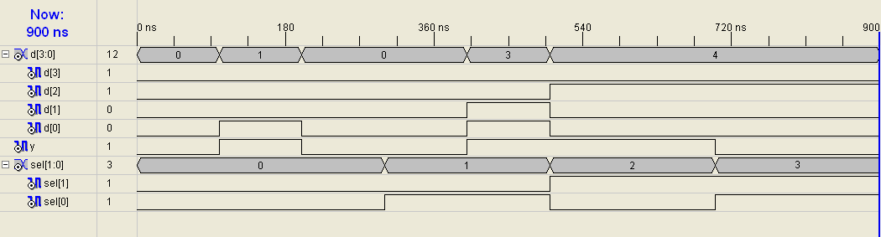

COMPARATOR USING IF ELSE

library IEEE;
use IEEE.STD_LOGIC_1164.ALL;
use IEEE.STD_LOGIC_ARITH.ALL;
use IEEE.STD_LOGIC_UNSIGNED.ALL;
entity comparator is
Port ( a,b : in STD_LOGIC_VECTOR (03 downto 0);
i : in STD_LOGIC_VECTOR (02 downto 0);
y : out STD_LOGIC_VECTOR (02 downto 0));
end comparator;
architecture Behavioral of comparator is
signal temp: std_logic_vector(2 downto 0);
begin
process(a,b)
begin
If(a <= b) then temp <= "001"; End If;
If (a >= b) then temp <= "100"; End If;
If (a = b) then
If (i = "010") then temp <= "010";

COMPARATOR USING IF ELSE

ElsIf (i = "100") then temp <= "100";
ElsIf (i = "001") then temp <= "001";
ElsIf( i ="101") then temp <= "000";
ElsIf (i = "000") then temp<= "101";
End If;End If;
End Process;
y <= temp;
End Behavioral;

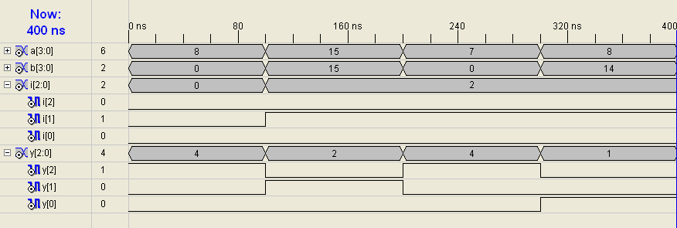

Floating Point Encoder
library IEEE;
use IEEE.STD_LOGIC_1164.ALL;
use IEEE.STD_LOGIC_ARITH.ALL;
use IEEE.STD_LOGIC_UNSIGNED.ALL;
entity float is
Port(data : in STD_LOGIC_VECTOR(10 downto 0);
M: out STD_LOGIC_VECTOR(3 downto 0);
e : out STD_LOGIC_VECTOR(2 downto 0));
end float;
architecture Behavioral of float is
begin
Process(data)
Begin
If(data(10) = '1') then
m <= data(10 downto 7);
e <= "111";
elsif (data(9) = '1') then
m <= data(9 downto 6);
e <= "110";
elsif (data(8) = '1') then
m <= data(8 downto 5);

Floating Point Encoder
e <= "101";
elsif (data(7) = '1') then
m <= data(7 downto 4); e <= "100";
elsif (data(6) = '1') then
m <= data(6 downto 3); e <= "011";
elsif (data(5) = '1') then
m <= data(5 downto 2); e <= "010";
elsif (data(4) = '1') then
m <= data(4 downto 1); e <= "001";
elsif (data(3) = '1') then
m <= data(3 downto 0); e <= "000";
End If;
End Process;
end Behavioral;
