EXP NO. : 2
TO FIND IMPULSE & STEP RESPONSE OF A SYSTEM

DIAGRAM:
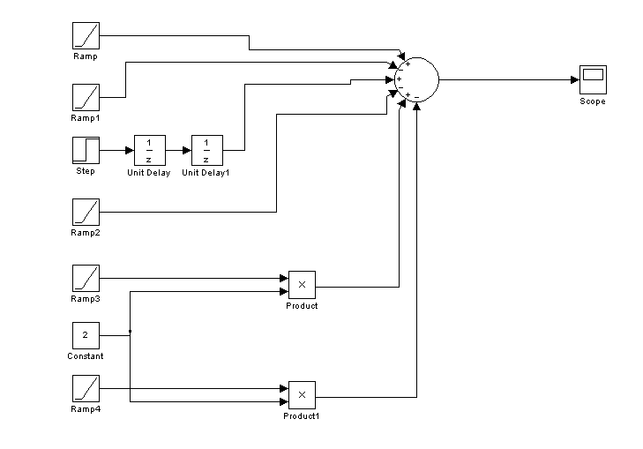

OUTPUT:

