.tran 1ms 3ms
.STMLIB "CLASS AB POWER AMP.stl"
* From [PSPICE NETLIST] section of c:\program files\PSpice\PSpice.ini:
.lib "nom.lib"
.INC "CLASS AB POWER AMP.net"
V_V2 $N_0001 0 25
C_C1 $N_0002 $N_0003 100uf
C_C2 $N_0002 $N_0004 100uf
R_R3 0 $N_0005 1k
R_R2 $N_0003 $N_0001 1k
R_R4 $N_0006 $N_0004 1k
Q_Q1 $N_0001 $N_0003 $N_0005 Q2N3904
D_D2 $N_0005 $N_0004 D10D2
D_D1 $N_0003 $N_0005 D10D2
V_V5 $N_0002 0 DC 0V AC 1v
+SIN 0V 1v 1khz 0 0 0
V_V1 0 $N_0006 25
Q_Q4 $N_0006 $N_0004 $N_0005 Q2N3906
.PROBE V(*) I(*) W(*) D(*) NOISE(*)
.END

D10D2
IS 10.010000E-21
ISR 195.300000E-06
BV 100
IBV 100.000000E-06
RS 1.000000E-03
TT 5.000000E-09
CJO 1.000000E-12
VJ .75
M .3333
Q2N3904 Q2N3906
NPN PNP
IS 6.734000E-15 1.410000E-15
BF 416.4 180.7
NF 1 1
VAF 74.03 18.7
IKF .06678 .08
ISE 6.734000E-15
NE 1.259
BR .7371 4.977
NR 1 1
RB 10 10
RC 1 2.5

CJE 4.493000E-12 8.063000E-12
MJE .2593 .3677
CJC 3.638000E-12 9.728000E-12
MJC .3085 .5776
TF 301.200000E-12 179.300000E-12
XTF 2 6
VTF 4 4
ITF .4 .4
TR 239.500000E-09 33.420000E-09
XTB 1.5 1.5
CN 2.42 2.2
D .87 .52

NODE VOLTAGE NODE VOLTAGE NODE VOLTAGE NODE VOLTAGE
($N_0001) 25.0000 ($N_0002) 0.0000

($N_0003) .2580 ($N_0004) -.2580

($N_0005) 42.24E-09 ($N_0006) -25.0000

VOLTAGE SOURCE CURRENTS
NAME CURRENT
V_V2 -2.474E-02
V_V5 0.000E+00
V_V1 -2.474E-02
TOTAL POWER DISSIPATION 1.24E+00 WATTS
JOB CONCLUDED
TOTAL JOB TIME .03

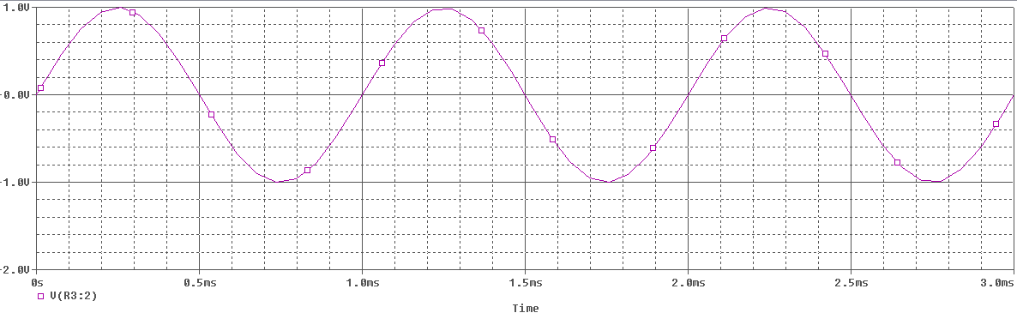v

