FS = 8000; % Sampling rate is 8000 samples per second.
FC = 300; % Carrier frequency in Hz.
t = [0:.1*FS]'/FS; % Sampling times for .1 second
x = sin(20*pi*t); % Representation of the signal.
y = ammod(x,FC,FS); % Modulate x to produce y.
figure;
subplot(2,1,1); plot(t,x,'r'); % Plot x on top.
subplot(2,1,2); plot(t,y,'g'); % Plot y below.

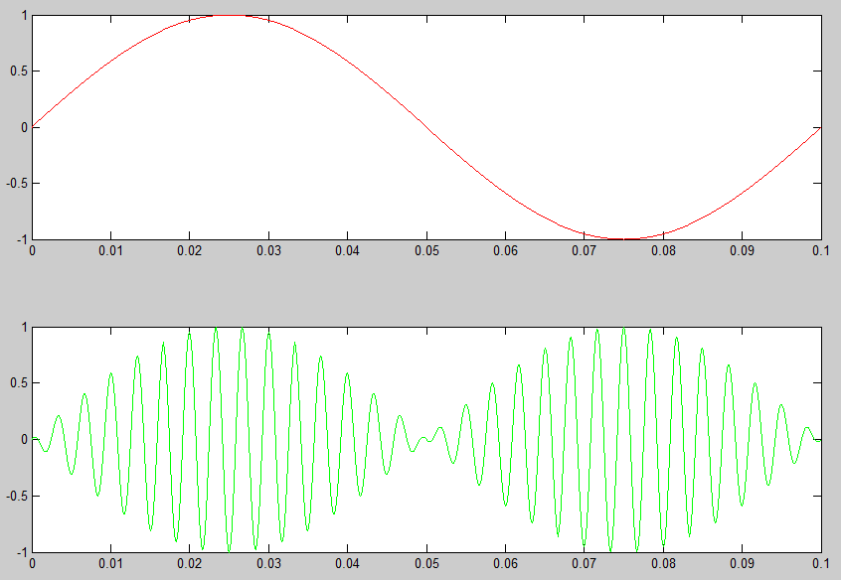

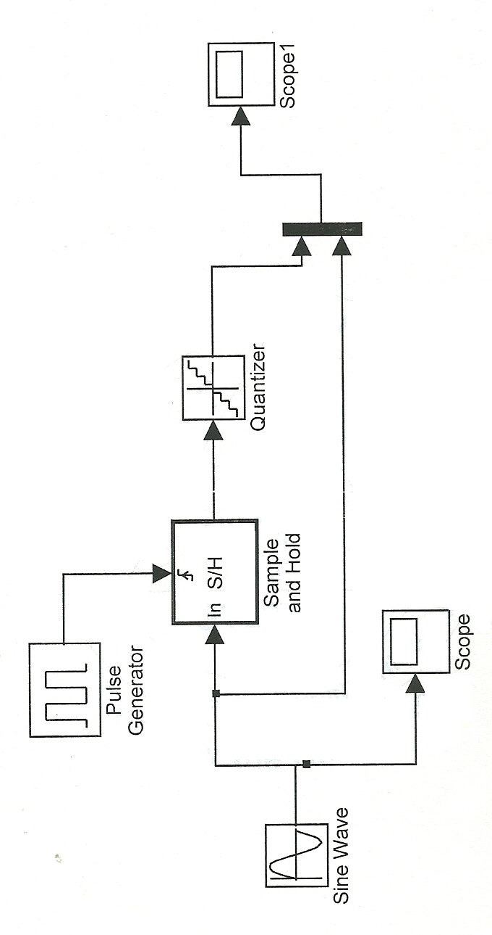

vin = input(‘pi input the modulating voltage’);
vc = input(‘pi input the carrier voltage’);
fm = input(‘pi input the modulating frequency’);
fc = input(‘pi input the carrier frequency’);
t = 0:00.00001:0.09999;
vm = vin*sin(2*pi*5*t);
vcr = vc*sin(2*pi*fc*t);
mod_ind = vin/vc;
subplot(3,1,1);
plot(t,vm);
subplot(3,1,2);
plot(t,vcr);
subplot(3,1,3);
vam = (vin*sin(2*pi*fm*t)).*(sin(2*pi*fc*t));
plot(t,vm);

